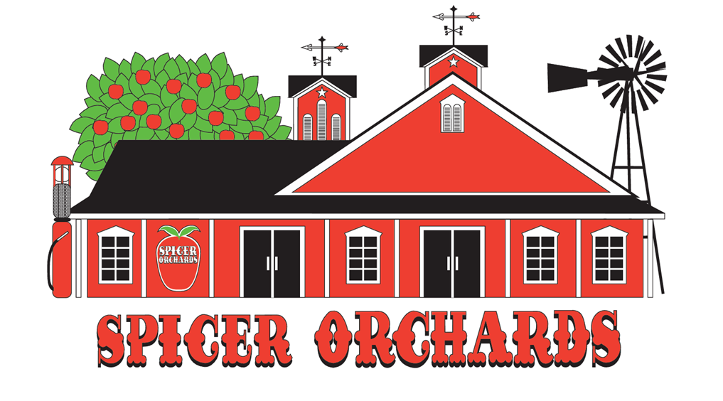

Field Trip Policies & Planning Guide

Contents
Part I — Field Trip Policies
- 1. Reservation and confirmation
- 2. Admission and payment
- 3. Attendance counts and group size
- 4. Tour format and timing
- 5. Lunch and pavilion use
- 6. Arrival, parking, and check-in
- 7. Weather and rescheduling
- 8. Clothing, restrooms, and handwashing
- 9. Accessibility and accommodations
- 10. Supervision, behavior, and safety
- 11. Farm Market shopping
- 12. Late arrivals and contact information
- 13. Written exceptions and controlling terms

Part I —Field Trip Policies
These policies are intended to provide one consistent standard for field trip planners and Spicer Orchards staff. They explain what groups should expect, what planners are responsible for, and how staff should apply fees, timing, attendance, and safety rules.

1. Reservation, Deposit, and Confirmation
A $50 non-refundable deposit is required to reserve a field trip date and time. The deposit is applied toward the group’s final balance on the day of the visit.

A reservation is not considered confirmed and the date and time are not guaranteed until the deposit has been received and a confirmation has been issued by Spicer Orchards.
The group coordinator must contact the Farm Market approximately one week before the scheduled visit to:
- Confirm the final attendance count
- Verify the arrival and tour time
- Review the selected tour and optional activities
- Confirm lunch or pavilion arrangements, if applicable
- Report accessibility needs or other accommodations
- Ask any remaining questions
A reminder email will also be sent before the visit. Confirmation calls should be made to (810) 632-7692.

The person making the reservation is the official group coordinator and is responsible for sharing these policies, arrival instructions, payment requirements, and supervision expectations with all teachers, chaperones, parents, and other participants.

Important
The final confirmation call and attendance update are due no later than seven calendar days before the visit. Changes requested after that deadline are subject to availability and are not guaranteed.
Rescheduling requests will be accommodated whenever possible, but availability is not guaranteed. Customer cancellations and no-shows forfeit the deposit. If Spicer Orchards cancels the trip and no mutually agreeable replacement date is available, the deposit will be refunded.

2. Admission, Included Activities, and Payment

Field Trip Pricing
All prices are per person. Every participant age 2 and older is included in the paid count unless a specific exception is stated in these policies.
Field Trip Package | Price
Summer Fruit Picking | $12 per person
Fall Apple or Pumpkin Only | $12 per person
Combination Apple & Pumpkin | $15 per person
Field trips are sold as a package. The experience may include:
- A welcome or introduction with a Spicer Orchards representative
- A wagon ride for the group
- A picking container or bag for available in-season fruit or produce
- Admission to the children’s play area and animal farm
- One donut and one cup of cider per paid participant
- A fruit sticker used as field trip admission identification
Field trip pricing is not reduced when a group chooses not to participate in one or more included activities. Please notify Spicer Orchards in advance if your group plans to skip an activity so the itinerary can be adjusted.
All participants age 2 and older must pay admission, including students, teachers, paraprofessionals, aides, chaperones, parents, grandparents, and siblings. Children age 1 and younger are admitted at no charge.
Accepted payment methods are cash, credit or debit card, and school or company check. Payment is due before the tour begins. The group coordinator must collect all funds before arrival; individual parents or students may not pay separately at check-in. Groups may also arrange advance payment by telephone.
Checks should include the school or organization name, teacher or group leader, and grade or class in the memo line so the payment can be matched to the correct reservation.
Spicer Orchards staff may verify the actual number of participants at check-in. Admission charges and operational fees will be based on the applicable guaranteed minimum or the actual number attending, whichever is greater.
Admission applies to every person attending as part of the group, whether or not that person participates in every included activity. A bus driver who remains with the bus and does not enter the tour, orchard, pavilion, playground, animal area, or other field trip activity space is not considered a participant.
No individual refunds or credits are issued for absent students, parents, or chaperones after the final count becomes guaranteed. Field trip admission stickers or other identifiers must be worn as directed, may not be shared or transferred, and are valid only for the scheduled visit.
The group coordinator is responsible for identifying and managing food allergies, medical needs, medication, emergency plans, and required support personnel. Spicer Orchards cannot guarantee an allergen-free environment. Declining the included snack does not reduce the admission price.

Donut Ingredients and Allergen Information
Traditional donuts are made with the following ingredients:
- Basic donut ingredients: Wheat flour, sugar, soybean oil, non-fat milk, whey, dextrose, soy flour, salt, leavening (sodium acid pyrophosphate, baking soda, and monocalcium phosphate), dried egg yolk, potato flour, nutmeg, and natural and artificial flavors.
- Shortening: Palm oil and cottonseed oil.
- Cinnamon topping: Cinnamon and sugar.
- Powdered sugar topping: Sugar and cornstarch, which is used to prevent caking.
Allergen information: A variety of allergens are used in the fudge, caramel apple, ice cream, and bakery areas. Peanuts and tree nuts are not used in the making of traditional donuts and are not used on the same donut fryers, conveyors, trays, or baking racks. However, peanuts and tree nuts are present in the bakery area for fudge production and in the fudge and ice cream areas, including for use in fudge and on caramel apples. Wheat, milk, egg, soy, peanuts, tree nuts, and soybeans are used in these areas. Spicer Orchards cannot guarantee an allergen-free environment.

Specialty Donut Options
Gluten-free donuts are available for an additional $4 per two-pack. They are made at the Spicer Orchards Farm Market using a gluten-free mix in a dedicated gluten-free fryer with dedicated gluten-free utensils and mixing equipment. The bakery itself is not a gluten-free environment, so cross-contact from the surrounding bakery area remains possible.
Vegan donuts from Mama Alana’s Pantry are available for $4 per donut. Vegan donuts are supplied by Mama Alana’s Pantry rather than made as part of Spicer Orchards’ traditional donut production. Guests with allergies or dietary restrictions should review the applicable product information before ordering. Spicer Orchards cannot guarantee an allergen-free environment.

3. Final Attendance Count and Reservation Range
The final count must include every person participating in the visit, including students, school staff, chaperones, parents, siblings, and other guests.
Because wagons, drivers, guides, staffing, and activity areas are scheduled according to the reserved attendance range, the coordinator must provide an updated count approximately seven days before the visit.
The group should remain within the minimum and maximum attendance range stated on the reservation. If the final count changes, contact the Farm Market before arrival so the reservation can be adjusted when space and staffing allow.
The confirmed count becomes the guaranteed minimum number billed unless Spicer Orchards approves a change. If actual attendance is higher than the confirmed count, charges will be based on actual attendance.
Up to five unannounced additional participants may be accommodated only when wagon capacity, staffing, and activity space permit. Accommodation is not guaranteed, and every additional participant must pay the applicable admission price.
Spicer Orchards is not required to admit unapproved participants when doing so would exceed wagon capacity, staffing levels, reserved space, or safe operating limits.
When an unannounced attendance increase requires an additional wagon, driver, or staffing adjustment, the $50 deposit will be forfeited. If the deposit has already been forfeited for another violation, a $50 additional wagon and staffing fee may be charged for each additional wagon required. These charges are separate from admission fees and the lunch reservation fee.

4. Large Groups - Larger than 3 groups of 40 people (3 classes)
To provide a safe, organized, and educational experience, large groups must be divided into smaller tour groups rather than moving through the farm as one oversized group.
Approximately 40 participants may be assigned to each wagon, depending on age, accessibility needs, equipment, and conditions. Each wagon or class group must include at least one responsible teacher or adult. A ratio of approximately one adult for every ten children is strongly recommended, with additional support for younger students or children who need closer supervision.
The approximately 40-person wagon assignment is a planning guideline, not a guaranteed capacity. Spicer Orchards staff will determine wagon assignments, rotations, and group divisions based on safe capacity and operating conditions on the day of the visit.
Schools and organizations with large attendance beyond 3 groups of 40 people should reserve multiple time slots or be prepared to remain in class-sized groups starting separately from each other. Spicer Orchards may rotate groups among the wagon ride, picking area, donut and cider station, playground, animal area, and lunch area. Rotations may be necessary because of group size, equipment availability, weather, crop conditions, or an unexpected operational issue such as a tractor breakdown.
Contact the Farm Market before booking a large group. Staff will help create a schedule that allows each class to receive the same high-quality experience.

5. Tour Length and Scheduled Departure
The guided portion of the field trip generally lasts 45 to 60 minutes. Combination tours, larger groups, rotations, and seasonal picking conditions may require additional time. Most groups spend approximately one hour in the playground and animal areas. Plan for approximately 2 to 2.5 hours, or longer when lunch is reserved. Unless the confirmation states otherwise, the entire visit may not exceed three hours.
Groups must depart by the end of their reserved field trip time. Multiple schools rotate through the orchard, playground, picnic areas, pavilions, and activity stations throughout the day. Remaining beyond the scheduled time can create overcrowding, delay incoming groups, and make supervision more difficult.
The on-site group leader is responsible for keeping the group on schedule, following the assigned itinerary, and allowing time for the tour, snack, reserved lunch, playground, shopping, and departure.
Spicer Orchards may change the order of the itinerary, including beginning with the donut and cider snack, to respond to weather, tour delays, equipment availability, staffing, or overcrowding. Staff will communicate changes as soon as reasonably possible, although some adjustments may be necessary without advance notice.
Weather, crop conditions, equipment availability, animal care needs, staffing, and other farm conditions may require activities to be shortened, relocated, reordered, substituted, or omitted. When the field trip proceeds, these operational adjustments do not automatically qualify the group for a refund or price reduction.
Farming is seasonal and weather-dependent. Spicer Orchards cannot guarantee the availability, quantity, variety, size, or condition of a particular fruit, vegetable, or pumpkin. If a scheduled crop is unavailable, Spicer Orchards may substitute another farm activity, product, or educational experience.
Arriving early does not extend the reserved field trip time. Groups may not enter the playground, animal area, pavilion, picking area, or other field trip activity spaces before their assigned time unless directed by staff.
Parents, chaperones, or other participants arriving separately must check in and complete any required payment before entering field trip areas. Individuals who arrive after the group has departed on a wagon or begun an activity may have to wait, may miss part of the experience, and are not entitled to a refund or extended time.
At the end of the reserved time, field trip admission privileges expire and the group must leave the playground, animal area, pavilion, and other reserved spaces. Groups that remain beyond their scheduled departure time may be charged an extended-use fee and may be refused future reservations.

6. Lunch and Pavilion Reservations
Groups that plan to bring and eat lunch on the property must reserve pavilion space in advance. The lunch reservation fee is $50. The fee reserves space, allows additional pavilion time, and helps cover setup, maintenance, and cleanup.
Lunch space is limited and assigned on a first-come, first-served basis. A group may call after booking to request lunch space, but availability is not guaranteed. Spicer Orchards may move a group to a different designated eating area if operational needs require it.
Groups that remain for lunch without a reservation may be charged the $50 lunch fee or may forfeit the $50 deposit. Pavilion use is generally limited to approximately 30 minutes for the included donut and cider snack, plus up to 30 additional minutes when lunch has been reserved.
Groups must vacate the pavilion at the end of the assigned time so it can be cleaned and prepared for the next reservation.
Groups may not remain on the property to eat a brought-in lunch unless lunch space has been reserved and confirmed. A group arriving without a confirmed lunch reservation may be required to depart at the end of its scheduled field trip because pavilion space may already be assigned to another group.
Any group meal involving brought-in food, lunch bags, coolers, pizza, catering, or food delivery is considered a lunch reservation. Outside food may be consumed only during the group’s confirmed lunch period and in the assigned area.
If space is available and Spicer Orchards permits an unreserved group to remain for lunch, the $50 lunch fee is due before lunch begins. Unauthorized pavilion use may also result in forfeiture of the deposit.
Grills, warming equipment, glass containers, and alcohol are prohibited unless specifically approved in writing by Spicer Orchards management.

7. Arrival, Parking, and Check-In
Arrive approximately 15 minutes before the scheduled start time. This allows time for parking, walking to the Pick Your Own pavilion, collecting the group, confirming attendance, completing payment, and preparing students before the tour begins.
Seasonal check-in instructions may differ:
- Summer visits (generally June through August): One group representative should check in at the Farm Market. Staff will direct the group to the meeting location.
- Fall visits (generally September through October): Groups normally meet at the red U-Pick/Tour Barn east of the Farm Market and Winery following the paved path up the hill to the Upick barn. Use the westernmost entrance marked for deliveries, proceed up and over the hill, park in the large lot, and walk to the barn unless the confirmation email gives different instructions.
Buses should use the Bus Parking/Overflow Lot west of the Farm Market. The main parking lot may not provide enough turning room for long buses or oversized vehicles. Groups needing an accessible drop-off must arrange it in advance.
Tours generally end near the playground area for convenient group pickup and departure as the busses are parked nearby.

8. Weather, Farm Conditions, and Rescheduling
Field trips are outdoor farm experiences. Groups should review the local forecast, prepare for changing Michigan weather, and contact Spicer Orchards the day before or the morning of the visit when rain or severe weather is expected.
Weather forecasts are not always accurate. Spicer Orchards monitors current weather, lightning, travel conditions, and farm conditions such as mud, standing water, slippery surfaces, and access to the orchard, pumpkin field, playground, and picnic areas.
Spicer Orchards—not the visiting school or organization—will make the final determination about whether farm conditions are suitable for the scheduled field trip. The goal is to avoid holding a trip when major activities would be unsafe or unavailable.
If Spicer Orchards determines that conditions are unsuitable, staff will attempt to reschedule the visit. If no mutually agreeable replacement date is available, the deposit will be refunded. If the group chooses to cancel while Spicer Orchards remains open and has not cancelled the trip, the normal customer cancellation policy applies and the deposit is forfeited.
If Spicer Orchards cancels the visit and no mutually agreeable replacement date is available, all amounts paid for services that were not provided will be refunded. If the group cancels while Spicer Orchards remains open, the deposit remains non-refundable and any additional prepaid amount will be handled according to the cancellation terms shown on the reservation.
The same Spicer Orchards cancellation and refund standard applies when the farm cannot safely or reasonably operate because of an emergency, power outage, equipment failure, government order, or another circumstance beyond normal control. Spicer Orchards is not responsible for transportation costs, substitute-teacher costs, or other expenses incurred by the group.

9. Clothing, Restrooms, and Handwashing
Field trips take place almost entirely outdoors. Participants should wear clothing appropriate for the local forecast and farm conditions.
- Closed-toe shoes are strongly recommended because surfaces may include dirt, gravel, grass, mud, and uneven ground.
- In warm weather, wear lightweight clothing and bring sun protection as appropriate. Slides in the playground can be hot, so pants are recommended.
- In cool weather, wear long pants, layers, a coat, and weather-appropriate footwear. Michigan mornings may be much cooler than the afternoon.
Restrooms and handwashing facilities are available near the playground pavilion, with additional restrooms on the north side of the Farm Market. Handwashing facilities are not available in the orchard or pumpkin field. Groups should bring hand sanitizer and disinfecting wipes, especially for use after picking produce, feeding animals, or participating in other farm activities. A water fountain is also available in the pavilion.

10. Accessibility and Special Accommodations
Spicer Orchards can generally accommodate approximately three to four wheelchairs on a wagon by advance arrangement. The group coordinator must report wheelchairs, walkers, mobility needs, sensory needs, or other required accommodations as early as possible.
Accessible wagon preparation may require additional staffing, equipment, and a coordinated drop-off location. If a group arrives with unreported accessibility needs that cannot be safely accommodated with the scheduled equipment and staff, the group may need to be delayed, modified, or rescheduled.
Advance notice allows Spicer Orchards to discuss available options but does not guarantee that every activity, route, wagon, or farm surface can be modified.
Pets and emotional-support animals are not permitted in field trip activity areas. Trained service animals are permitted as required by law; advance notice is strongly encouraged because the visit includes farm animals, wagons, and agricultural areas.

11. Supervision, Conduct, and Property Care
Teachers, chaperones, and group leaders are responsible for actively supervising children throughout the visit, including during the wagon ride, picking activities, snack, lunch, playground time, animal visits, restroom breaks, and Farm Market shopping.
Children must remain with their assigned class or group and follow staff instructions. Groups may be required to provide additional chaperones when students need closer behavioral or physical support.
Spicer Orchards maintains zero tolerance for threatening, abusive, or aggressive behavior toward employees or other guests. A group may be asked to leave, charged for damaged property, denied access to an activity, or refused future reservations because of unsafe conduct, inadequate supervision, intentional damage, theft, or abusive treatment of staff.
Spicer Orchards employees do not assume custody of students and are not responsible for taking attendance, conducting head counts, supervising restroom trips, locating separated participants, administering medication, or providing one-on-one behavioral support.
Wagon riders must remain seated while the wagon is moving and keep hands, feet, and belongings inside the wagon. Standing, climbing on rails, changing seats, throwing objects, or boarding and exiting without staff permission is prohibited. Staff may stop or end a ride when behavior becomes unsafe.
Participants must remain outside animal enclosures. Children may not chase, climb on, pick up, or feed animals except in designated areas and with approved feed. Chaperones are responsible for ensuring handwashing or sanitizing after animal contact and before eating.
Produce may not be eaten in the field unless Spicer Orchards staff expressly permits it. Groups must follow all picking instructions, including where to pick, what may be picked, and how much is included. Produce picked beyond the amount included in the package must be paid for before departure.
Injuries, missing participants, property damage, or other emergencies must be reported to Spicer Orchards staff immediately. Group leaders remain responsible for contacting parents, guardians, school officials, emergency contacts, or medical personnel as required by their organization.
Spicer Orchards is not responsible for lost, stolen, damaged, or unattended personal property, including phones, bags, coolers, strollers, school supplies, or items left on buses, wagons, playgrounds, or pavilions.
Participants are entering an active farm with uneven ground, fallen limbs or crop debris, wildlife activity, vehicles, tractors, and operating machinery. Participants must remain in designated guest areas and may not enter employee-only, equipment, storage, or production areas.
Smoking, vaping, alcohol use, and possession of unlawful substances are prohibited in field trip activity areas.

12. Farm Market Shopping
Whether students are permitted to shop is determined by the school or organization and the available schedule. The Farm Market remains open to the public during normal business hours.
Teachers and chaperones must closely supervise students in the Farm Market. The store contains breakable merchandise, food displays, toys, and other items that can be damaged when children are not properly supervised.
The school or organization is responsible for identifying participants who may not be photographed and for communicating those restrictions to its staff, chaperones, and families. Schools remain responsible for managing their own student privacy requirements.

13. Late Arrivals and Contact Information
Call the Farm Market as soon as possible if the bus or group is running late. Staff will make reasonable efforts to accommodate the delay, but activities may need to be shortened, reordered, or omitted so later reservations are not disrupted. Traffic, bus problems, school delays, and late-arriving participants remain the responsibility of the visiting group. Staff may not promise replacement activities, complimentary products, refunds, or extended time. The scheduled ending time will not be extended because of a late arrival. Activities or pavilion time missed or shortened because the group arrived late are not refundable.
Questions, reservation updates, attendance changes, accessibility requests, and weather calls should be directed to (810) 632-7692.

14. Written Exceptions, Courtesy Waivers, and Controlling Terms
Exceptions or changes to these policies are valid only when confirmed in writing by an authorized Spicer Orchards manager. Statements by drivers, guides, seasonal employees, or other staff members do not change the reservation terms unless management confirms the change in writing.
A courtesy, refund, fee waiver, or accommodation provided on one occasion does not change these policies or create an entitlement to the same exception in the future.
If an advertisement, FAQ, prior email, verbal statement, or older document conflicts with the current reservation confirmation or Tour Terms and Conditions, the terms in effect on the date of booking and included with the reservation confirmation will control.
By paying the deposit, checking the acceptance box during online booking, or proceeding with the visit after receiving the confirmation, the organization acknowledges that its coordinator received and accepted the policies applicable to the reservation.

Spicer Orchards Farm Market
Phone: (810) 632-7692

Appendix — Current Location Map
The location map below is provided for planning purposes. Check-in locations, parking instructions, and walking routes may change by season or because of farm operations; groups must follow the directions in their current confirmation email and instructions from staff upon arrival.
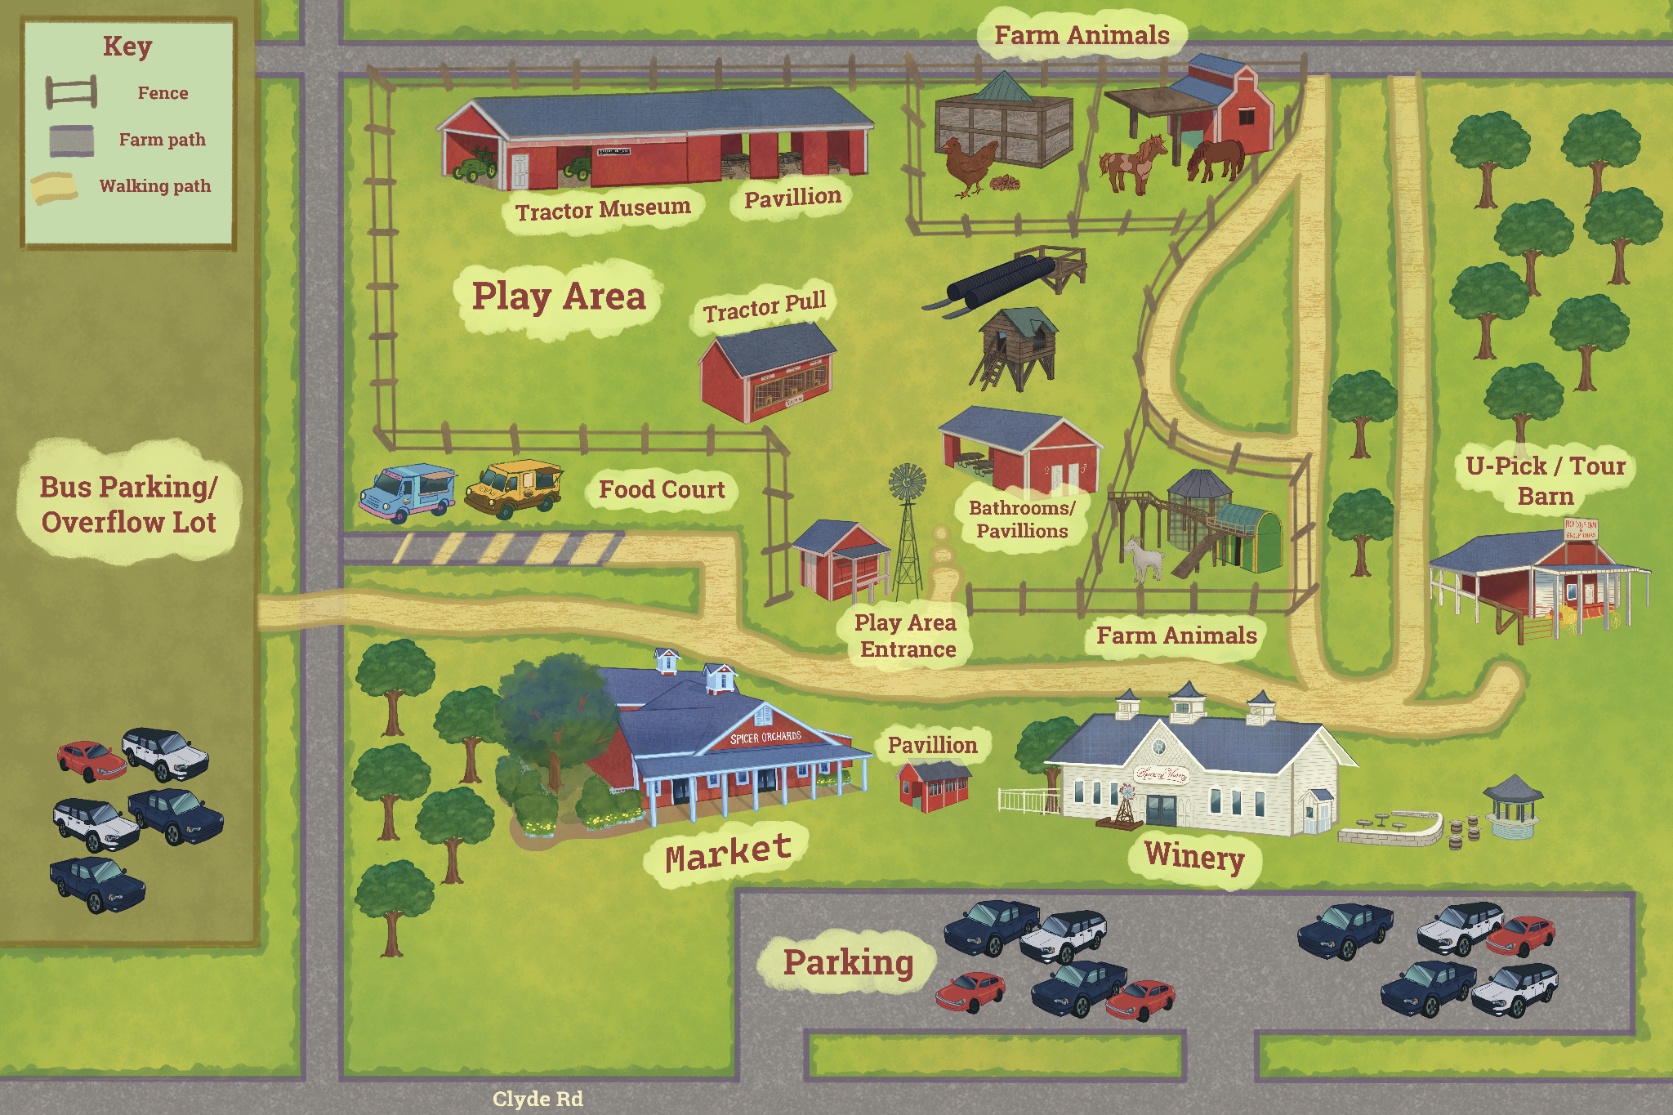
Note: The Food Court is generally available only on weekends during September and October.

Part II — Bus Driver Information
  - A one-page operating guide for drivers transporting field trip groups.
Give this page to every driver. Drivers should also receive the current confirmation email or arrival map because seasonal routes and parking instructions may change.

Before Leaving the School
☐ Confirm the destination is Spicer Orchards Farm Market and save the Farm Market phone number: (810) 632-7692.
☐ Review the group’s scheduled arrival time, departure time, seasonal check-in location, and parking instructions.
☐ Ask the trip leader whether an accessible drop-off has been arranged for wheelchairs, walkers, or other mobility needs.
☐ Plan to arrive approximately 15 minutes before the scheduled start time. Early arrival does not extend the group’s reserved field trip time.

Arrival and Parking
☐ Long buses should use the Bus Parking/Overflow Lot west of the Farm Market unless the confirmation email or Spicer Orchards staff gives different directions.
☐ The main parking lot may not provide enough turning room for long buses or oversized vehicles. Do not attempt a turn or drop-off that appears unsafe.
☐ Short buses may be directed to a different area. Follow the current confirmation instructions and all directions from staff upon arrival.
☐ Do not block fire lanes, customer traffic, delivery routes, farm equipment routes, or entrances.
☐ If the group is running late, call (810) 632-7692 as soon as safely possible. The scheduled ending time will not be extended because of a late arrival.

During the Visit
- A driver who remains with the bus and does not enter the tour, orchard, pavilion, playground, animal area, or other field trip activity space is not charged admission.
- A driver who participates in field trip activities is considered a participant and must be included in the paid attendance count.
- Remain reachable by the trip leader and be prepared to move the bus if requested for farm operations or emergency access.

Pickup and Departure
☐ Confirm the pickup location with the on-site group leader or staff; tour ending points may change.
☐ Load only after the trip leader completes a head count, and be ready to depart promptly at the reserved ending time.

Part III — Payment Representative Instructions
  - For the person responsible for attendance totals, payment, and check-in.
One person should handle payment. Individual parents or students may not pay separately at check-in. Arrive with the final count and one group payment ready.

Seven Days Before the Visit
☐ Call (810) 632-7692 to confirm the final attendance count, arrival and tour time, selected activities, lunch reservation, and any accommodations.
☐ Include every participant age 2 and older: students, teachers, paraprofessionals, aides, chaperones, parents, grandparents, siblings, and participating bus drivers.
☐ The confirmed count becomes the guaranteed minimum billed unless Spicer Orchards approves a change. If actual attendance is higher, charges are based on actual attendance.
☐ Make sure the trip coordinator and on-site teacher understand who will bring the payment and where that person will check in.

Prepare the Payment
Use the confirmed package and the guaranteed minimum or actual attendance, whichever is greater, to prepare the group payment.
Field Trip Package | Price
Summer Fruit Picking | $12 per person
Fall Apple or Pumpkin Only | $12 per person
Combination Apple & Pumpkin | $15 per person
Payment item | What to know
Deposit | $50 non-refundable deposit; applied toward the final balance.
Admission | Due for every participant age 2 and older, even if the person skips one or more included activities.
Lunch reservation | $50 when the group has reserved pavilion space to eat a brought-in lunch.
Possible operational fees | May apply for unannounced attendance increases, an additional wagon or staffing adjustment, unauthorized lunch use, property damage, or extended use.
Accepted methods | Cash, credit/debit card, or school/company check.
Check memo | Include school or organization name, teacher/group leader, and grade or class.

☐ Collect all funds before arrival. Individual parents or students may not pay separately at check-in.
☐ Accepted forms of payment are cash, credit or debit card, and school or company check.
☐ For checks, include the school or organization name, teacher or group leader, and grade or class in the memo line.
☐ Add the $50 lunch reservation fee when lunch has been confirmed.
☐ Add any confirmed specialty donut charges: gluten-free donuts are $4 per two-pack, and Mama Alana’s Pantry vegan donuts are $4 each.

At Check-In
☐ Arrive approximately 15 minutes early with an accurate actual head count.
☐ Tell staff immediately about absent participants, unexpected additional participants, separately arriving adults, or any change from the confirmed count.
☐ Spicer Orchards staff may verify the actual number of participants. Charges are based on the guaranteed minimum or actual attendance, whichever is greater.
☐ Complete payment before the tour begins. Admission stickers or identifiers must be used as directed and may not be shared or transferred.

Important Payment Rules
- No individual refunds or credits are issued for absent students, parents, or chaperones after the final count becomes guaranteed.
- Declining donuts, cider, picking, playground time, or another included activity does not reduce the package price.
- Up to five unannounced additional participants may be accommodated only when capacity and staffing permit. Accommodation is not guaranteed.
- Only an authorized Spicer Orchards manager may approve a refund, fee waiver, complimentary service, or exception. Obtain any exception in writing.

Part IV — Teacher and Chaperone Guide
  - A practical guide for the adults supervising children during the visit.
Spicer Orchards staff guide the activities; school adults supervise the children. Teachers and chaperones remain responsible for students at all times, including on wagons, in restrooms, during lunch, in the playground, around animals, and inside the Farm Market.

Before the Trip
☐ Review the itinerary, assigned class or wagon group, meeting location, departure time, and emergency plan.
☐ Know which adults are responsible for medication, allergies, medical plans, behavior support, mobility support, and students who may not be photographed.
☐ Dress children for an outdoor farm visit. Closed-toe shoes are strongly recommended; pants are recommended when playground slides may be hot.
☐ Bring hand sanitizer and disinfecting wipes. Handwashing is not available in the orchard or pumpkin field.
☐ Tell children that they must stay with their assigned group and follow all instructions from teachers, chaperones, drivers, and Spicer Orchards staff.

Supervision Expectations
- Maintain active supervision and conduct head counts whenever the group changes locations, boards or exits a wagon, leaves a restroom area, or prepares to depart.
- Spicer Orchards employees do not assume custody of students, supervise restroom trips, administer medication, provide one-on-one behavioral support, or locate separated participants.
- Keep children out of employee-only, equipment, storage, production, and animal enclosure areas.
- Report a missing child, injury, property damage, unsafe condition, or emergency to Spicer Orchards staff immediately.
- The visiting school or organization remains responsible for contacting parents, school officials, emergency contacts, or medical personnel.

Wagon, Picking, Animal, and Playground Safety
- On wagons, everyone must remain seated while moving and keep hands, feet, and belongings inside. No standing, rail climbing, seat changing, throwing, or boarding/exiting without permission.
- Follow picking instructions about where to pick, what may be picked, and how much is included. Produce may not be eaten in the field unless staff permits it.
- Children may not enter animal enclosures, chase animals, pick up animals, or feed animals except in designated areas with approved feed.
- Ensure children wash or sanitize their hands after animal contact and before eating.
- Closely supervise playground use. Farm surfaces may be uneven, muddy, slippery, or contain crop debris.

Snack, Lunch, Shopping, and Departure
☐ Manage food allergies and dietary restrictions. Spicer Orchards cannot guarantee an allergen-free environment.
☐ Review the donut ingredient and allergen information before the trip. Traditional donuts contain wheat, milk, soy, and egg ingredients. Peanuts and tree nuts are not used in traditional donut production equipment, but peanuts and tree nuts are present elsewhere in the bakery, fudge, caramel apple, and ice cream areas. The bakery is not an allergen-free environment.
☐ Gluten-free donuts are available for an additional $4 per two-pack and are made with dedicated gluten-free fryer, utensils, and mixing equipment; however, the bakery itself is not a gluten-free environment. Mama Alana’s Pantry vegan donuts are available for $4 each.
☐ Outside food may be eaten only during a confirmed lunch reservation and in the assigned area.
☐ Supervise children closely in the Farm Market. The store is open to the public and contains breakable merchandise, food displays, and toys.
☐ Keep the group on schedule. Shopping, lunch, or late arrival does not extend the reserved departure time.
☐ At the scheduled end time, promptly gather the group, complete a head count, and depart the reserved areas.

Part V — Off-Site Trip Coordinator Guide
  - For the person who books and organizes the trip but will not attend in person.
Your responsibility continues even when you do not attend. The person who makes the reservation is the official group coordinator and must transfer all information and responsibilities to the on-site leader before the trip.

Assign On-Site Roles in Writing
Role | Required responsibility
On-site trip leader | Receives the full confirmation, keeps the group on schedule, communicates with staff, and makes operational decisions.
Payment representative | Brings the final attendance count and one group payment; completes check-in before the tour.
Bus contact | Has arrival, parking, accessible drop-off, pickup, and late-arrival instructions.
Class/wagon leaders | Know their assigned students and adults; conduct head counts and supervise their group.
Medical/allergy contact | Manages medication, emergency plans, allergies, and required support personnel.
Lunch lead | Confirms whether lunch is reserved and ensures the group vacates the pavilion on time.

Information You Must Send to the On-Site Leader
☐ Current confirmation email and reservation details
☐ Full Field Trip Policies and Planning Guide
☐ Bus Driver Information page
☐ Payment Representative Instructions
☐ Teacher and Chaperone Guide
☐ Current map, seasonal check-in location, and parking directions
☐ Final guaranteed count and attendance breakdown
☐ Payment method and amount due
☐ Lunch reservation and assigned time, if applicable
☐ Accessibility arrangements and emergency contacts
☐ Spicer Orchards phone number: (810) 632-7692

Seven-Day Confirmation Checklist
☐ Call Spicer Orchards no later than seven calendar days before the visit.
☐ Confirm the final guaranteed count, reservation range, arrival time, tour time, selected package, lunch, and accommodations.
☐ Report whether parents or other adults will arrive separately.
☐ Verify that the on-site leader understands that unapproved participants are not guaranteed admission.
☐ Confirm that the school has collected funds and that one representative will make the payment.
☐ Confirm any gluten-free or vegan donut requests and make sure the payment representative knows the additional charges.
☐ Provide the on-site leader with authority to communicate with Spicer Orchards and respond to itinerary changes.

After You Transfer the Trip
Send the on-site leader’s name and cell phone number to Spicer Orchards if requested. Remain available by phone on the day of the visit for school-level questions, but understand that the on-site leader must follow Spicer Orchards staff directions regarding safety, timing, rotations, activity substitutions, and departure.

